PHENIKAA UNIVERSITY
UNIVERSITY OF INFORMATION TECHNOLOGY



COURSE PROJECT
SOFTWARE ARCHITECTURE

DESIGN OF A COMIC BOOK READING APP

Instructor: Vu Quang Dung
Group members: Group 10
Student: Pham Nhat Anh (23010323)

Course : K17
Field/Specialization: Information Technology

Hanoi, 2025

CHAPTER 1: INTRODUCTION TO THE TOPIC
1.1. Reasons for choosing the topic
In the digital age, the demand for entertainment through reading manga on mobile devices is constantly increasing. However, managing a massive manga library, ensuring fast image loading speeds, and synchronizing personal data across devices remains a challenge for many current applications.
The topic "Building a comic book reading application on the Flutter platform " was chosen with the aim of researching how to combine the framework. Flutter (for optimized interface) and the Firebase platform (for optimized storage infrastructure) have resulted in a product that delivers a great user experience.
1.2. Objectives of the research topic
The project focuses on achieving the following objectives:
- Technically: Master the framework. Flutter is used to build cross-platform applications. Firebase is used as a backend - as -a- service ( BaaS ) to manage real-time data.
- Regarding features:
  - Allows users to log in using their Google account .
  - Provides a smooth reading interface with image caching capabilities.
  - Manages a user's list of favorite stories and reading history.
  - Provides tools for administrators to update stories and new chapter content.
1.3. Research Subjects and Scope
- Research subjects: Libraries within the Flutter ecosystem ( firebase_auth , cloud_firestore , firebase_storage ) and the cloud data management model.
- Scope: Mobile applications for the Android operating system (according to the project folder structure) and comic book data stored on Firebase .
1.4. Technology used in the project
pubspec.yaml configuration file , the project implements the following key technologies:
- Framework : Flutter (SDK ^3.9.2) - Helps develop user interfaces quickly and smoothly.
- Backend & Database :
  - firebase_core , cloud_firestore : Manages the NoSQL database storing story and chapter information.
  - firebase_storage : Stores the image files of the comic book.
- Authentication : firebase_auth combines with google_sign_in to securely identify users.
- System Utilities:
  - flutter_cache_manager : Optimizes image loading, helping users save bandwidth and read stories faster.
  - connectivity_plus : Monitors network status to notify users when connection is lost.
  - shared_preferences : Stores lightweight configuration settings (such as light/dark mode or user preferences) locally on the machine.

CHAPTER 2: SYSTEM ANALYSIS
2.1. Functional Requirements
Based on installed libraries ( Firebase) (Auth , Firestore , Storage ), the system needs to meet the following functional groups:
- User management: Registration, login via Google , personal information management.
- Content management: View story list, read chapter content, search for stories.
- Interaction: Add stories to your favorites list, save your reading history.
- Admin : Uploading stories, managing chapters and images .
2.2 . Actors
The system has two main actors:
- User : A person who uses the application to search for and read stories .
- Administrator ( Admin ): Responsible for updating manga content and managing the data system on Firebase .
General Use Case Diagram
Note: You should use tools like Draw.io or StarUML to draw the image based on this description.
- User Agent :
  - Log in (via Google) Sign in).
  - View the list of the latest stories.
  - Searching for stories.
  - Reading stories (retrieving data from Firestore and photos from Storage ).
  - Add the story to your "Favorites" list.
- Loading agent :
  - Log in to the system.
  - Add/Edit/Delete manga .
  - Upload chapters and images to Firebase . Storage via image_picker .
2.4. Detailed description of key use cases
2.4.1. Use Case : Login ( Authentication )
- Agent: User , Admin .
- Description: Users use their Google accounts to verify their identity in the system.
- Event flow:
  - The user selects "Sign in with Google ".
  - google_sign_in library to retrieve account information.
  - firebase_auth authenticates and creates/updates user information in Firestore .
  - The system displays a successful login notification and returns to the main screen.
2.4.2. Usecase : Reading a story ( Read) Manga )
- Agent: User .
- Description: Users view the content of the comic pages for a specific chapter.
- Event flow:
  - The user selects a series from the list.
  - Firestore query system retrieves a list of chapters .
  - Users select the chapter they want to read.
  - The system loads a list of image URLs from Firestore , then uses flutter_cache_manager to display images from Firebase. Storage .
  - If the network connection is lost, connectivity_plus will notify the user.
2.4.3. Use Case : Manga Management Management​
- Agent: Admin .
- Describe: Admin adds a new series or updates information for an existing series.
- Event flow:
  - The admin selects the "Add new story" function.
  - The admin enters the name and description and uses the image_picker to select the cover image.
  - System for uploading cover images to Firebase Store and retrieve the URL.
  - The system saves all information (including image URLs) to a collection . manga on the Cloud Firestore .
2.5. Non-functional requirements
- Usability: Smooth interface (uses Material Design) Flutter 's design makes it easy to use.
- Performance: Image loading speed must be fast thanks to caching ( flutter_cache_manager ).
- Stability: Works well on various Android versions (SDK ^3.9.2).
- Security: User data is secured through Firebase. Authentication .

CHAPTER 3: ARCHITECTURAL DESIGN (C4 MODEL)
3.1. Introduction to the C4 model
The C4 model ( Context , Container , Component , Code ) is used to describe the software architecture at different levels, making it easier for stakeholders to visualize the data flow and structure of the MangaApp1 system.
3.2. Level 1: Context Diagram ( System) Context Diagram​
Describe the interaction between the application, the user, and external systems.
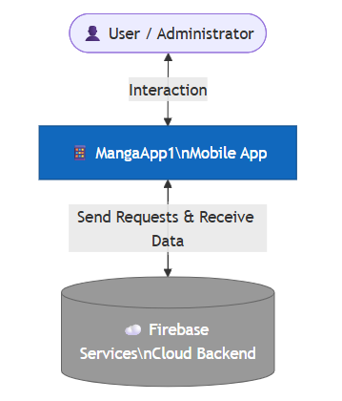
- Manga App ( System ): The main system that allows you to read stories.
- User / Admin ( Person ): The user of the application on a mobile device.
- Firebase Services ( External) System : Google 's cloud storage and authentication system .
- Interaction flow:
  - Users send login/story reading requests to the app .
  - The app sends authentication requests and data queries to Firebase .
  - Firebase returns the results (user information, story data).
3.3. Level 2: Container Diagram ( Container) Diagram​
Describe the main execution components in the system and how they communicate.
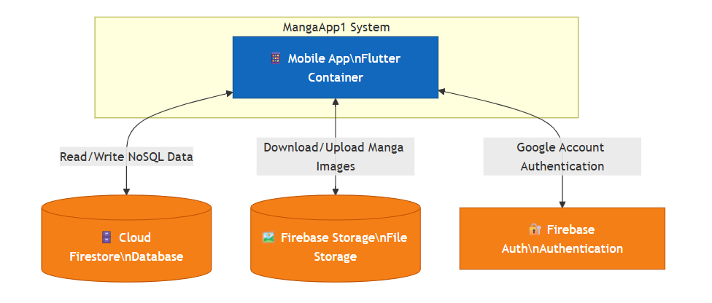
- Mobile App ( Flutter) Container : An application that runs on the user's machine, handling display and navigation logic .
- Database ( Cloud) Firestore : A NoSQL database that stores information about stories, chapters, and users.
- File Storage ( Firebase) Storage : Stores large comic book image files.
- Auth Service ( Firebase) Auth : Handles Google login and session management.
- Data flow:
  - Flutter The app uses the HTTPS protocol (via the Firebase SDK) to synchronize data with Firestore .
  - The app uses image URLs from Firestore to download images from storage .
Component Diagram Diagram​
Delve deeper into Mobile An app to describe functional modules based on pubspec.yaml .
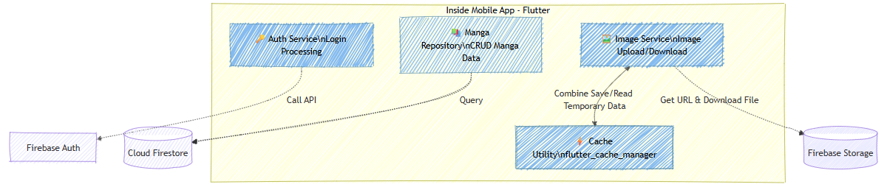
- Authentication Component :
  - Use firebase_auth and google_sign_in .
  - Function: Handles login flow, authorization, and account security.
- Manga Data Component :
  - Use cloud_firestore .
  - Create , Read , Update , Delete ) queries on the list of stories.
- Instagram Resource Component :
  - Use firebase_storage and image_picker .
  - Function: Allows the administrator to select images from their device and upload them to the server , and also to upload images for users to view.
- Utility & Optimization Component :
  - flutter_cache_manager : Manages image caching, ensuring smooth reading even with a weak internet connection.
  - connectivity_plus : Checks the internet status before making a data request.
  - shared_preferences : Stores local settings (e.g., Night mode, unfinished reading episodes).
3.5. Level 4: Source Code Diagram Diagram / Architecture​
The system is organized according to a layered architecture . Architecture ) to ensure ease of maintenance:
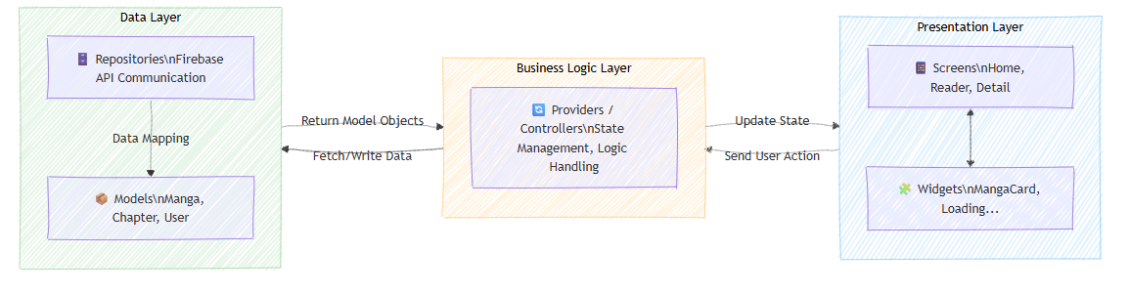
- Presentation Layer (UI): Contains Screens ( Home , Reader , Detail ) and Widgets .
- Business Logic Layer ( Controller / Provider ): Handles data flow, filters stories by genre, and formats dates using the intl library .
- Data Layer ( Repository ): These classes work directly with the Firebase API to retrieve raw data and transform it into a Model .
3.6. Details of system components ( System) Components​ 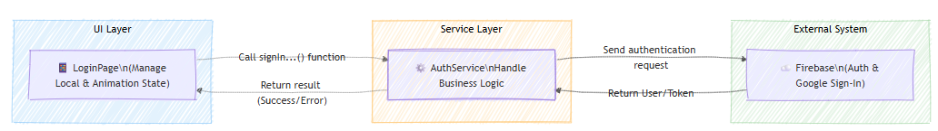
3.6.1 . Service Layer Layer​
To separate business logic from the user interface (UI), the project implements services . Specialized classes . This helps keep the source code clean and highly reusable.
- AuthService :
  - Use the firebase_auth and google_sign_in libraries .
  - Function: Handles login via Email / Password using the signInWithEmailAndPassword function and login via Google using the signInWithGoogle function .
  - Programming mindset: Encapsulating authentication logic in a separate class allows the LoginPage screen to simply call the function without needing to worry about the complex internal processing details of Firebase .
- Manga & Storage Service :
  - Use cloud_firestore to perform story data queries (CRUD).
  - Use firebase_storage in conjunction with image_picker to manage image files.
  - The retrieved data is then mapped to the models . Objects are easier to manage in Flutter .
State Management Management​
The project applies a combination of state management methodologies appropriate to each data scale:
- Local State (Using setState ):
  - Used in widgets with simple, local state.
  - For example, in LoginPage , the setState function is used to change the variable _isPasswordVisible , allowing users to instantly hide/show their password. This is an optimal approach for logic that doesn't affect the entire application.
- Animation State (State of motion):
  - Use AnimationController and SingleTickerProviderStateMixin in _LoginPageState .
  - The system controls the animation state of the interface (such as the fade -in effect when opening the app ) through the _animationController.forward () command. This demonstrates a focus on user experience (UX).
- Persistent State (Stable state):
  - Use shared_preferences to store small but important state information that needs to be retained after the application closes (such as remembering login status or user personal settings).
3.6.3. System support utilities ( Utility) Layers​
Declaring supporting libraries in the pubspec.yaml file plays a crucial role in completing the system:
- Image optimization: The integrated flutter_cache_manager library manages caching. Instead of always loading images from Firebase. Storage : The system will check the local cache first, which helps applications run faster and saves network bandwidth.
- Time handling: The intl library is used to format date data from Firestore into user-friendly character strings for Vietnamese users (e.g., dd /MM/ yyyy format ).
- Check the connection: connectivity_plus allows applications to react promptly to network conditions, preventing runtime errors when executing Firestore queries without an internet connection .

CHAPTER 4: SYSTEM ARCHITECTURE MODEL
4.1. Overall Architecture ( System) Architecture​
The system is built on a Client -Server model based on a Cloud platform . In this model, Flutter acts as the Client and Firebase acts as the Server ( Backend - as -a- Service ).
4.1.1. Flowchart
- UI Layer : Receives user interaction (swipe, tap to select a comic).
- Business logic​ Logic ): Uses Providers / Blocs to process data. For example, when the user presses "Read", the logic will check the network connection using connectivity_plus .
- Data Layer Layer ):
  - Query Metadata (title, author) from Cloud Firestore .
  - Download image files from Firebase Storage .
  - Use flutter_cache_manager to temporarily store images in the device's memory, reducing latency for subsequent reads.
4.2. Software Architecture in Flutter ( Folder) Structure )
To ensure the project is easily scalable, the source code is organized in a layered structure:
- models /: Defines data objects ( Manga , Chapter , User ).
- services /: Contains classes that interact with the Firebase API ( AuthService , FirestoreService ).
- views /: Contains the interface screens ( Home , Detail , Reader ).
- widgets /: Shared UI elements ( MangaCard , LoadingWidget ).
- utils /: Utility functions (Date format using intl , network check).
Database Design Design​
NoSQL database . Cloud Firestore . The collection structure is designed to optimize query performance:
4.3.1. Collection : users Stores identifier information from firebase_auth .
- uid : String ( Primary Key​
- email : Range
- DisplayName : Range
- photoUrl : Range
- lastLogin : Homestamp
4.3.2. Collection : mangas. Stores general information about manga series.
- mangaId : Range
- title : Range
- author : Range
- description : Range
- thumbnail : String (URL from Firebase) Circuit​
- genres : Array (List of categories)
- Rating : True
4.3.3. Sub-collection : Chapters (Located within each Manga )
- chapterId : Range
- chapterNumber : Int
- title : Range
- pages : List <String> (List of URLs of image pages stored on Firebase ) Circuit​
- createdAt : Timestamp (Use intl to display on UI)
4.3.4. Collection : favorites Stores the relationship between the user and the story.
- userId : String (Linked to users )
- mangaId : String (Linked to mangas )
- addedAt : Homestamp
4.4. Storage and Optimization Solutions
- Image storage: All comic images are stored on Firebase. Storage . The app uses image_picker so that the admin can upload images directly from mobile devices.
- Caching : Integrates flutter_cache_manager to manage local image storage. When the user flips a page, the system checks the cache before loading new images from Storage .
- Local configuration: Use shared_preferences to save minor customizations such as:
  - The position of the last chapter I'm reading.
  - Reading mode (Vertical scrolling or horizontal flipping).
  - Dark state Mode .

CHAPTER 5: DATABASE DESIGN
5.1. Choosing a storage technology
Firebase ecosystem for data management:
- Cloud Firestore : A document - oriented NoSQL database used to store text information, story structure, and user information.
- Firebase Storage : Stores physical files (page images, cover images) as binaries . impressive Objects ( BLOBs ).
5.2 . Structure of Collections
In Firestore , data is organized into Collections and Documents . Below is the detailed design for MangaApp1:
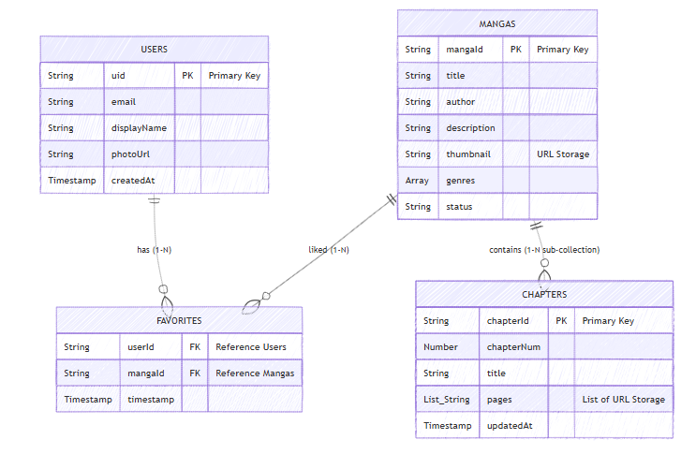
5.2.1. Collection : users
Store user details after authentication via google_sign_in .
School name | Data type | Describe
uid | Range | Unique identifier ( Primary) Key​
e-mail | Range | User's registration email
displayName | Range | Display name
photoURL | Range | Profile picture link
createdwith | Homestamp | Account creation time
5.2.2. Collection : mangas
This is the main collection containing information about the comic series.
School name | Data type | Describe
mangaId | Range | Firestore 's automatically generated ID
title | Range | Title of the series
language | Range | Author's name
description | Range | Summary of content
Consumer | Range | Cover image URL (saved in Firebase) Circuit​
genres | Array | List of genres ( Action , Romance ,...)
status | Range | Status (In progress/Completed)
5.2.3. Sub-collection : chapters (Located in mangas /{ mangaId }/)
To optimize loading performance, the chapter lists are designed as sub-collections of each series.
School name | Data type | Describe
chapterId | Range | Chapter ID
chapterNum | True | Chapter number
title | Range | Chapter Title
page | List <String>​​ | List of image URLs for comic pages
updatedAt | Homestamp | Chapter update date
5.2.4. Collection : favorites
Store a list of each user's favorite stories.
School name | Data type | Describe
userId | Range | User ID (Reference to users )
mangaId | Range | Manga ID (Reference to manga )
timestamp | Homestamp | Time to add to favorites
5.3. Image storage process ( Firebase) Circuit​
Images are organized into folders to avoid conflicts:
- Cover image link: manga_thumbnails /{mangaId}.jpg
- Link to the comic page: manga_content /{ mangaId }/{ chapterNum }/{page_index}.jpg
Execution flow:
- Admin : Use image_picker to select images from your computer/phone library -> Upload to Firebase Storage -> Get Download URL -> Save this URL to Firestore .
- User : The app reads URLs from Firestore -> Uses flutter_cache_manager to load and temporarily cache images in the device's memory, reducing bandwidth usage for subsequent reads.
Security Rules Rules​
To ensure data security, the system establishes the following rules:
- Users : Only users with matching UIDs have the right to edit their personal information.
- Mangas / Chapters : Regular users only have Read permission. Only Admin accounts have Create , Update , and Delete permissions .

CHAPTER 6: SUMMARY AND FUTURE DEVELOPMENT
6.1. Results achieved
After the research and project implementation process, the system has achieved the initial objectives:
6.1.1. From a technical standpoint
- Mastering Frameworks Flutter : Successfully built a cross-platform application with stable performance (SDK ^3.9.2).
- Firebase ecosystem integration :
  - Secure user authentication via firebase_auth and google_sign_in .
  - Flexible data management with NoSQL cloud_firestore .
  - Store and retrieve images efficiently with firebase_storage .
- Optimized experience: Applying flutter_cache_manager reduces bandwidth load and speeds up image display. The system also handles connection loss issues well thanks to connectivity_plus .
6.1.2. In terms of function
- Users can log in, search, and read comic books smoothly.
- The "Favorites" function works reliably, and data is synchronized across user accounts in the cloud.
- Admins can manage story content and upload new chapters directly through the application using image_picker .
6.2. Advantages and limitations of the system
6.2.1. Advantages
- Interface: Modern, adhering to Material Design principles. The design is mobile-friendly.
- Speed: Thanks to the caching mechanism , pages that were read the first time will appear instantly the next time you read them.
- Flexibility: Easily expand to include new story genres or features without affecting the existing data structure.
6.2.2. Limitations
- Storage space: Due to storing high-quality images on Firebase. If images are not compressed properly, storage will consume a lot of storage resources.
- Offline features : Currently, the application only caches pages that have been read; it does not yet support the "Download entire series" feature for completely offline reading.
6.3. Future Development Directions
To make the application more complete and professional, the next development directions include:
- Download Feature : Develop a module to download comics to your computer as local files so users can read them offline .
- Community interaction: Adding commenting , reviewing , and notification features ( Firebase ) Cloud (Message ) when a new chapter is released.
- Recommendation system: Uses user reading data to suggest similar series through basic algorithms.
- Admin Optimization Tool : Build a web -based dashboard to allow administrators to manage data more effectively, instead of relying on mobile devices .
6.4. Conclusion
The application development project has fully met the requirements for system analysis ( Usecase ), architecture (C4 Model ), and practical database design. This provides a solid foundation for developing a complete commercial product in the digital entertainment field.

REFERENCES
The reference materials are divided into the following main source groups:

Official documents Documentation​
- Flutter Developer : https://docs.flutter.dev/
  - The primary source of information on widgets , application lifecycle, and UI optimization.
- Firebase Documentation : https://firebase.google.com/docs/flutter/
  - Detailed instructions on configuring authentication and cloud storage services.
- Dart Language : https://dart.dev/guides
  - This course provides knowledge of the Dart language and asynchronous programming ( Async / Await ) used in services . Layer .

2. Libraries and Communities ( Open) Origin Packages​
- Pub.dev : https://pub.dev/ - A repository of open-source packages for Flutter .
  - Look up how to use google_sign_in for cross-platform authentication.
  - image caching solutions via flutter_cache_manager .
- Material Design 3: https://m3.material.io/
  - Guidelines for modern interface design applied to UI elements in LoginPage .

3. Academic and community support resources
- Stack Overflow : * A reference source for resolving issues arising from platform compatibility issues . Adaptive ) for the Google login button on Desktop and Mobile .
- Medium ( Flutter) Community : * Refer to analytical articles on Clean architecture Architecture and how to separate Services Layers in a Flutter project .

